**How to:**

**Flash RSR RE20 respirator software**

# Summary of developments

**Version 1.0**

10/07/2020 : M. JACONELLI - Initial version

**Table of contents**

1. Summary of developments 1

2. Prerequisite 3

2.1 Document objective 3

2.2 Before starting… 3

3. Programming procedure 4

3.1 Probe connection 4

3.2 Respirator software programming 6

# Prerequisite

## Document objective

This document is intended to explain how to program RSR RE20 respirator.

## Before starting…

Before trying to program the respirator, make sure you have:

* A computer with Windows 7, 8 or 10 (32 or 64 bits)
* A RSR RE20 respirator with V3 motherboard
* A STLINK-V3SET debugger
* 4 wires to connect debugger to motherboard
* A USB Type-A to Micro-B cable
* Programming software STM32CubeProgrammer version 2.4.0 (available [here](https://www.st.com/en/development-tools/stm32cubeprog.html) for free)

# Programming procedure

## Probe connection

To flash respirator software in V3 motherboard, debugger STLINK-V3SET should be used:

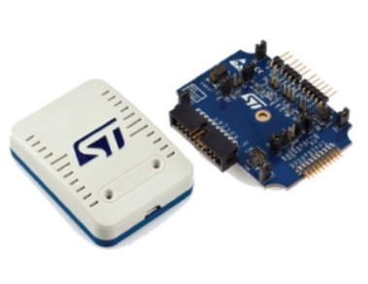

**Before connecting the probe to the computer or the motherboard, both computer and motherboard must be disconnected from electrical network!**

The debugger is connected to computer with an USB Type-A to Micro-B cable.

It’s connected to the motherboard with 4 wires, according to the following picture:

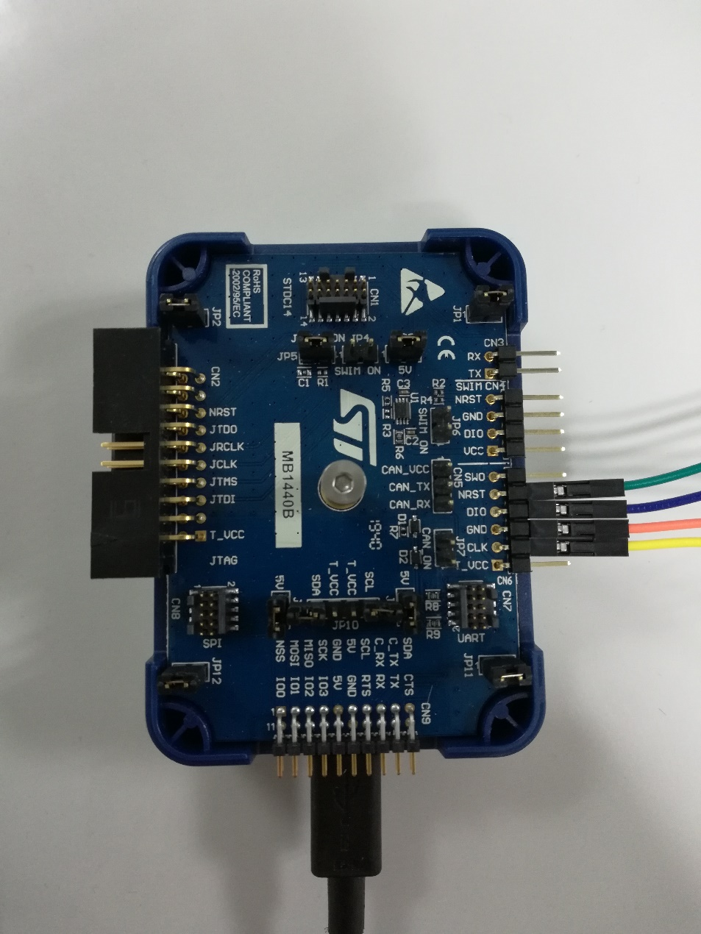

* Green wire is connected to NRST pin of the probe
* Blue wire is connected to DIO pin of the probe
* Orange wire is connected to GND pin of the probe
* Yellow wire is connected to CLK pin of the probe

On the motherboard side, wires must be connected to SWD connector (a 5 pins connector):

* First pin remains unused (from top to bottom)
* Blue wire is connected to 2nd pin of SWD connector
* Orange wire is connected to 3rd pin of SWD connector
* Yellow wire is connected to 4th pin of SWD connector
* Green wire is connected to 5th pin of SWD connector

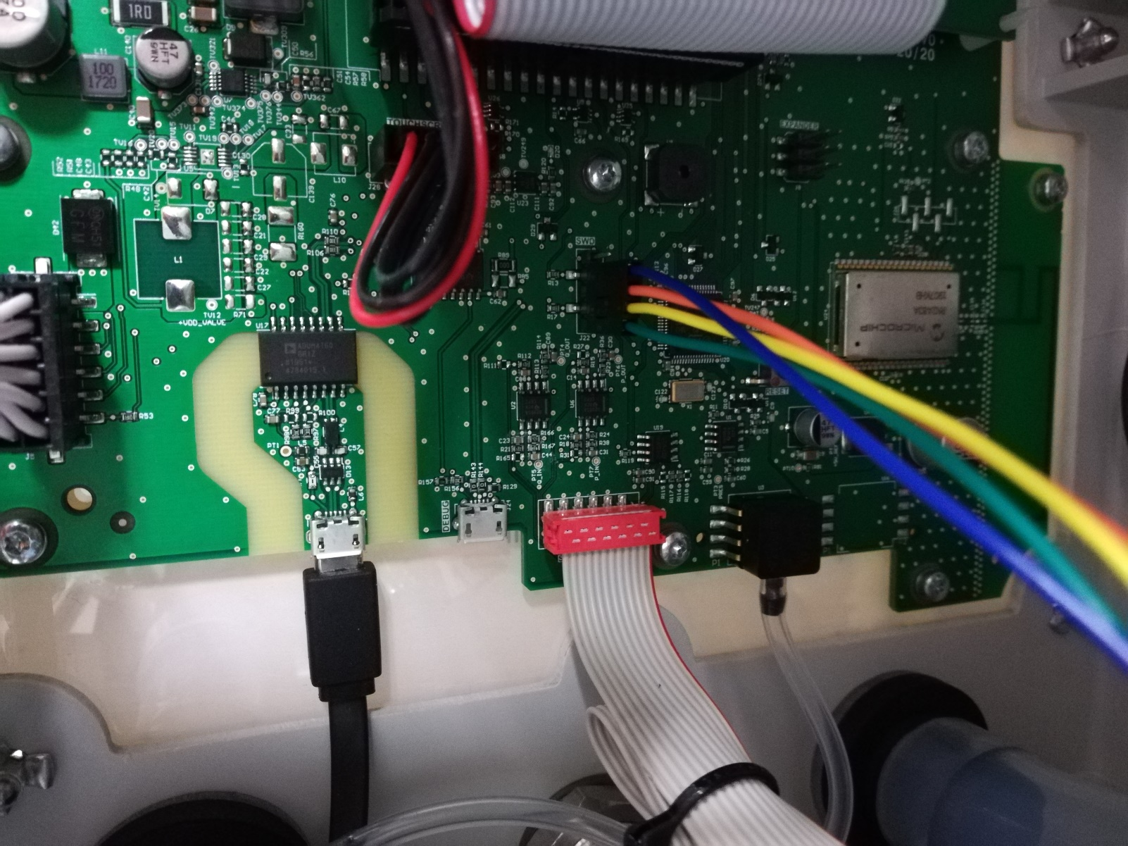

When probe is connected to computer and motherboard, then both can be plugged to electrical network, and respirator can be switched on using its main switch located on the backside.

## RSR RE20 respirator software programming

First, launch STM32CubeProgrammer software.

Once STM32CubeProgrammer software is launched, the following main window is displayed:

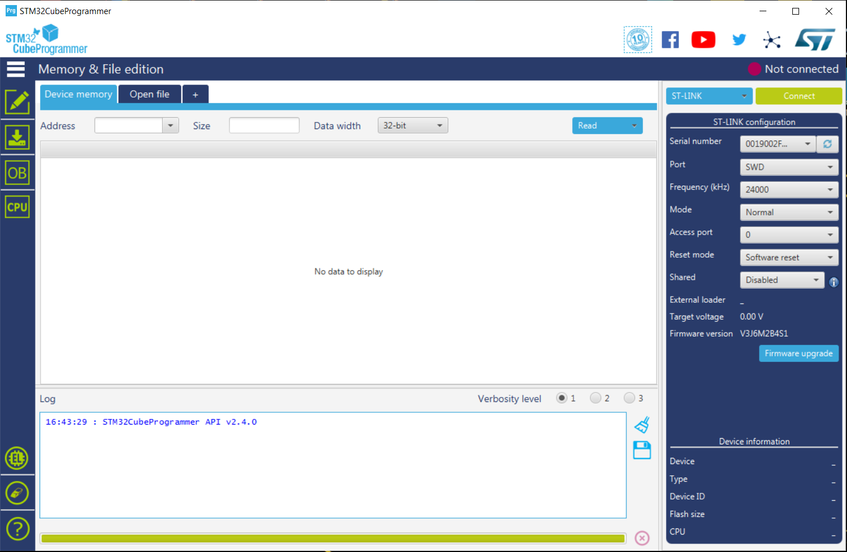

In the “ST-LINK configuration” panel on the right part of the window, information about the connected probe are mentioned (Serial number, …).

To establish connection with debugger, simply click on button which is located on the top right part of the window.

Once connection is established, the window should look like the following:

* Status on the top right part displays
* “Device memory” tab is filled with processor data

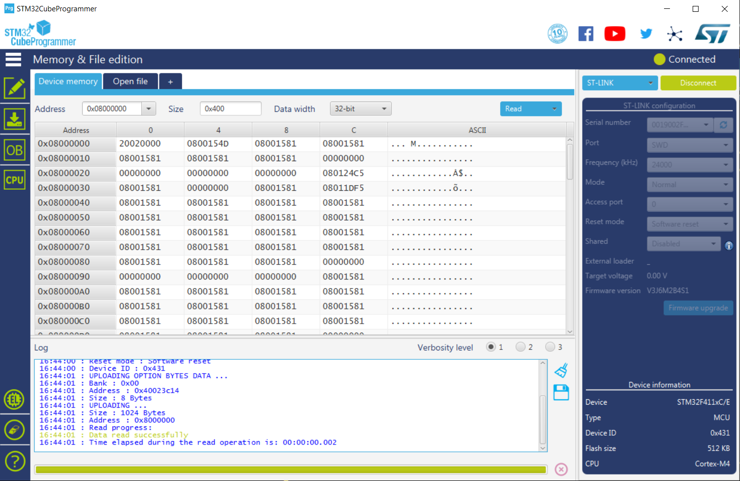

Now, select the software to be programmed (a .bin file) by clicking on button (located on top left part of the window).

When the firmware file (.bin file) is loaded, the “Open file” tab is replaced by a tab which has the file’s name:

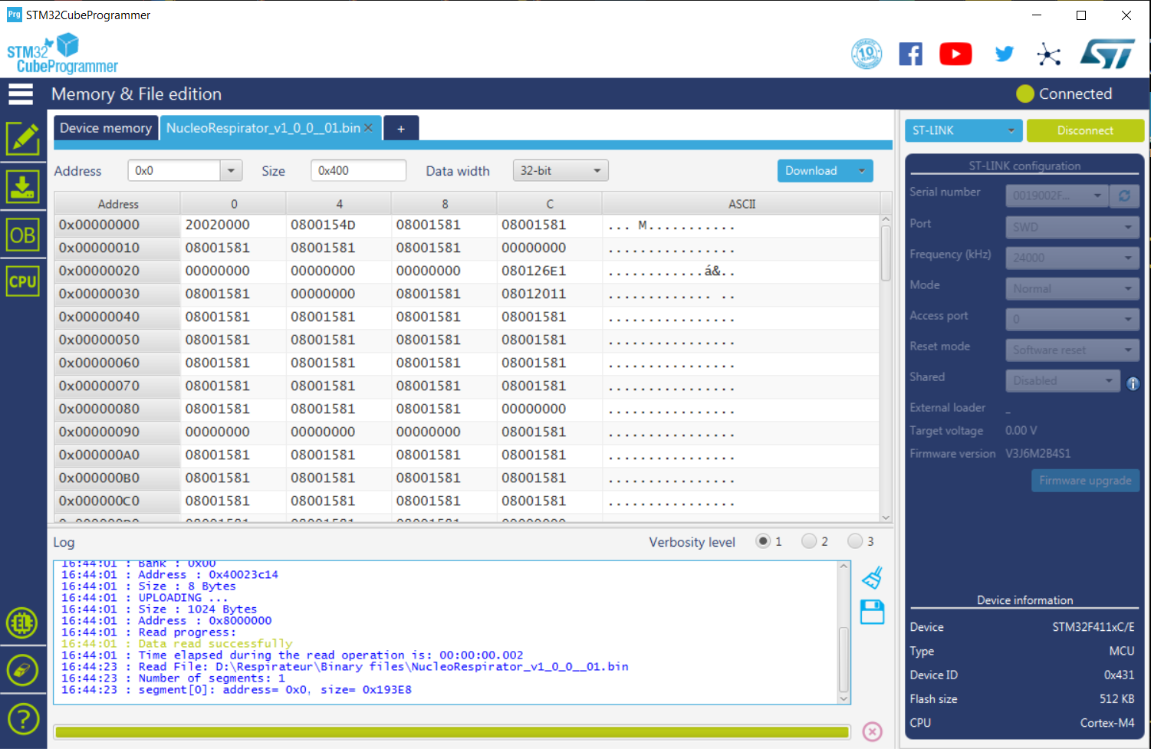



To program the processor with the loaded firmware file, just click on

At the end of the programming sequence (which lasts only a few seconds), a pop-up window appears, just click on OK.

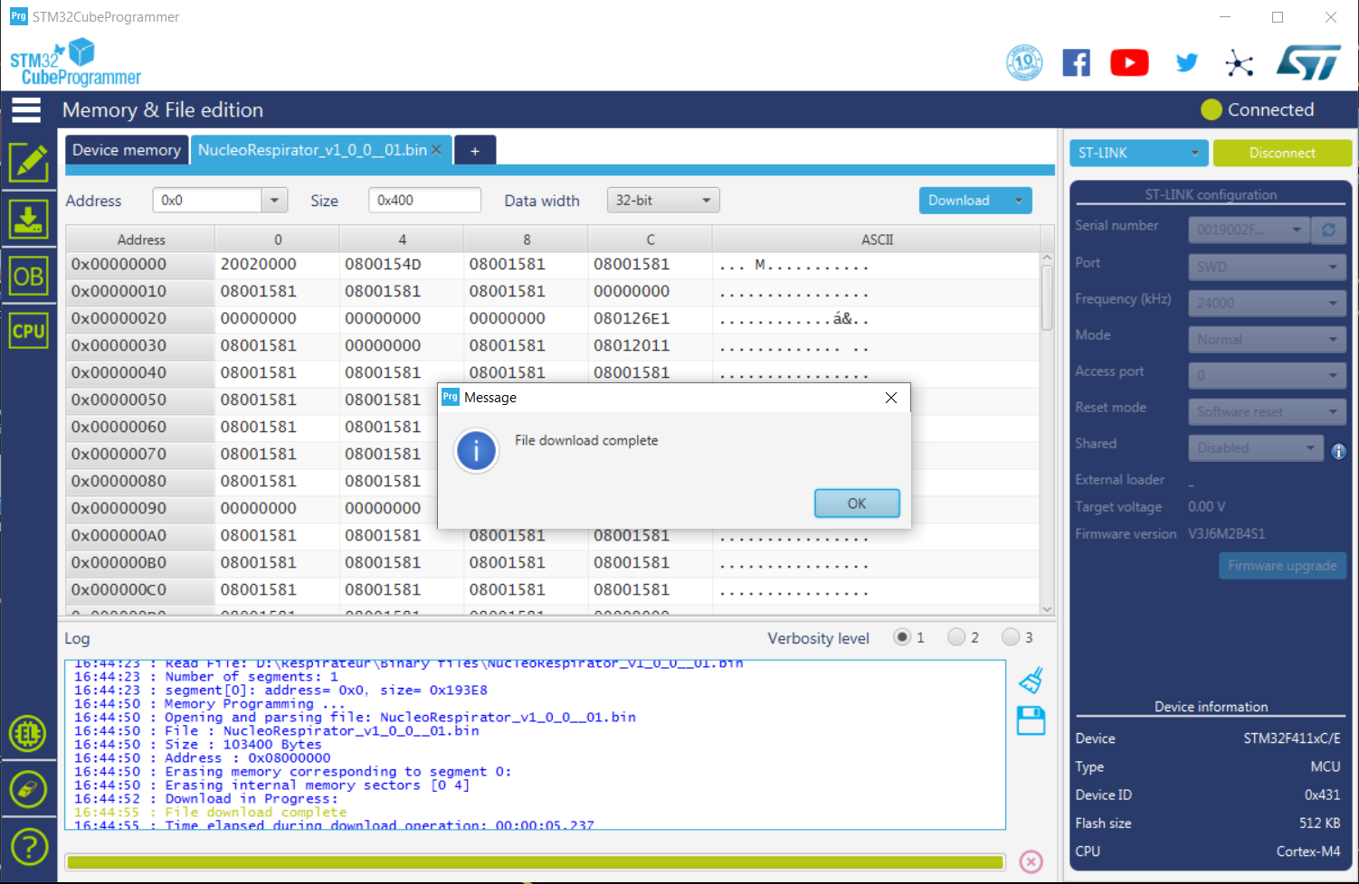



After that, debugger can be disconnected by clicking on button which has replaced the button on the top right part of the window.

When it’s done, status displays and STM32CubeProgrammer can be closed.

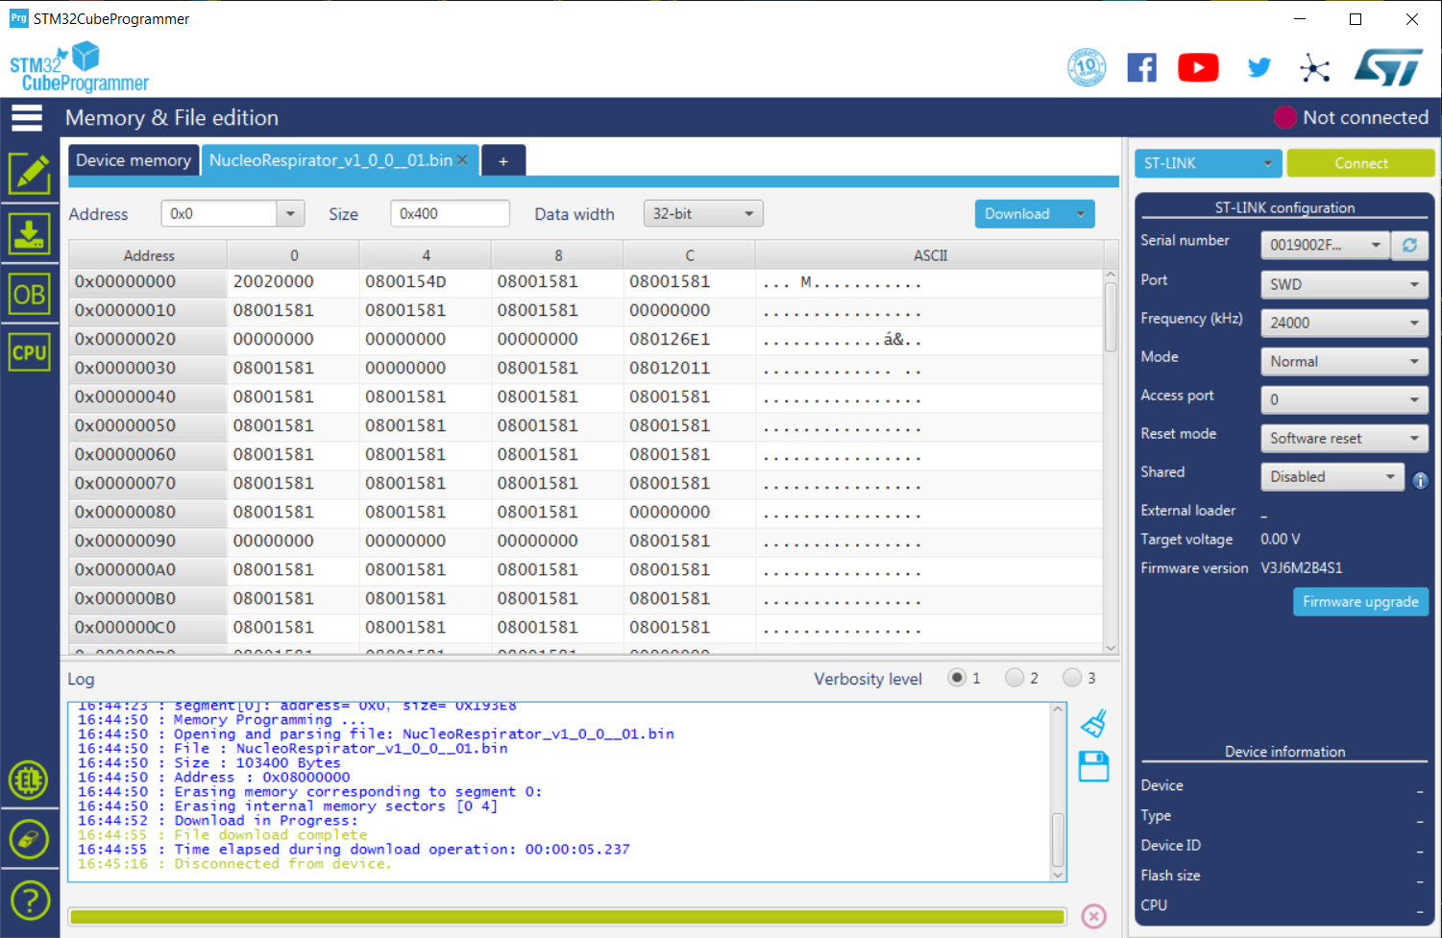

**To finish properly, respirator has to be switched off and unplugged from electrical network. Debugger can then be disconnected from motherboard and computer.**

The new software is ready to be used at the next start of the RSR RE20 respirator.